

Geospatial Analysis

GEOSPATIAL RAP
User manual

Developer: CEMIC
Authors: Fernando Poletta, Juan Gili, Maximiliano Giordano
Version 2.0

Intended Users, Administration, and Adaptation to Other Contexts
This application is intended to support public health surveillance and response activities, and may be used by healthcare professionals, public health officers and other personnel responsible for reporting, reviewing, managing or analysing epidemiological information. Depending on the implementation context, the administration, configuration and maintenance of the application may also be carried out by municipal or regional health secretariats, by public health authorities, or by local National Statistical Office (NSO) teams.
The examples, screenshots and simulated datasets included in this document are based on the administrative and data structure used by INDEC in Argentina, and are provided as a reference implementation. The application can nevertheless be adapted for use in other countries and institutional settings, regardless of whether a given country has an established national epidemiological surveillance system in place. Detailed guidance on adaptation, configuration and implementation in other national contexts is provided throughout this Technical Documentation, as well as in the additional technical, support and version-control materials available in the project's GitHub repository.
The National Statistical Office (NSO), or an equivalent national technical authority, may support users by providing guidance on how to interpret the outputs of this tool. This support may include advice on data quality, geographic standardisation, and the appropriate use of spatial indicators within national public health and statistical frameworks.

Geospatial-RAP tool
User manual
Prevalence mapping and spatial cluster analysis
Documentation revision | June 2026
Language | English
Status | Aligned with the supplied current application source provided

Contents

1. Purpose and scope 3
Important limitation 3
Interpretation 3
2. Input data and spatial requirements 4
Configured map data 4
Identifier matching 4
3. Configure and run 5
Current controls 6
Population handling in week ranges 6
4. Review the outputs 7
Global Moran's I banner 7
Prevalence map 7
LISA cluster map 9
Results table 10
Prepared data 11
Display settings 12
5. Interpret results responsibly 12
6. Downloads 13
7. Troubleshooting 13
Escalation package 14
8. Glossary 14

1. Purpose and scope
This manual is intended for public health analysts, epidemiologists, surveillance teams and other users who need to run the Geospatial-RAP tool and review its outputs. It explains how to prepare the input data, run the analysis, review the maps and tables and interpret the results. Technical setup, country configuration and deployment are described separately in the Developer and Administrator Guide.
The Geospatial-RAP tool aggregates cases and population for a selected country, administrative level, year and epidemiological week window. It produces prevalence maps, a Global Moran's I summary and Local Moran's I (LISA) cluster classifications.

Important limitation
All units at the selected geographic level are analysed together. The standalone application does not require users to select each commune, department or other location separately. Once a geographic level has been chosen, all matching units available in the active data are processed in the same run.

Interpretation
Spatial statistics describe patterns in the selected dataset. They do not establish causation, identify a source of transmission or replace local epidemiological investigation.
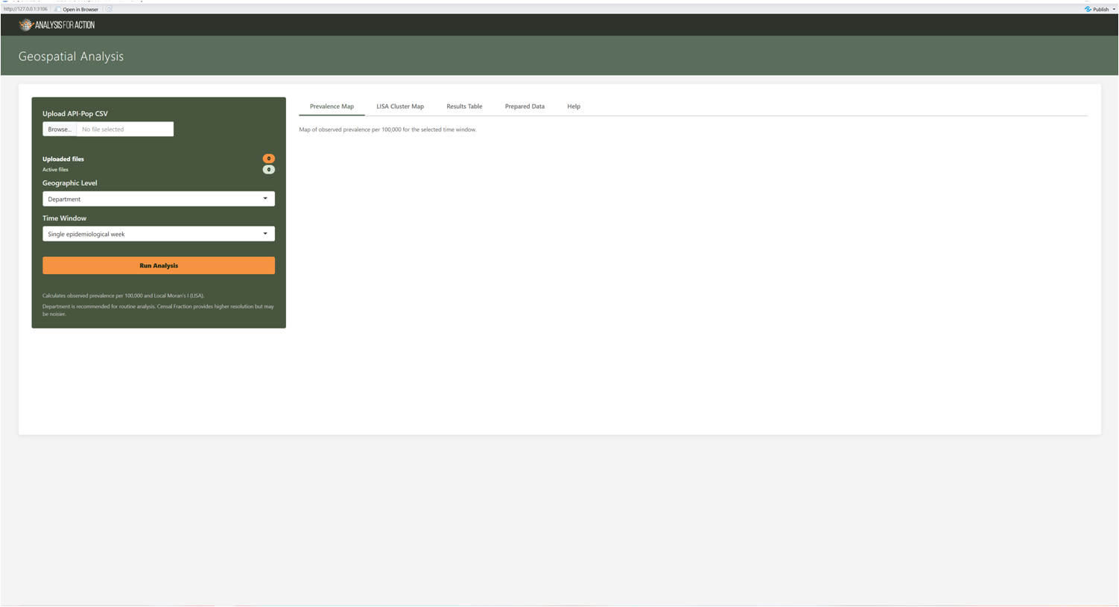Figure 1. The Geospatial-RAP interface.

2. Input data and spatial requirements
Upload one or more API-POP-compatible CSV files. The files may come directly from API-POP or from another source, provided that they follow the required structure and geographic coding rules. Both comma-delimited and semicolon-delimited files are supported. Population is required, because prevalence is calculated as the number of cases divided by the population and multiplied by the configured rate multiplier, currently 100,000.
Internal column | Required | Meaning | Accepted aliases or examples
year | Yes | The epidemiological year. | year, anio, año, epiyear
week | Yes | The epidemiological week.. | week, semana, epiweek, se
country | Recommended | The country or national unit. | Argentina or England
level1 | Depends on selected level | The first administrative level. | province, region, Level1
level2 | Required for second-level maps | The second administrative level. | department, district, LAD, Level2
level3 / level4 | Required for detailed maps | More detailed administrative levels. | fraction, MSOA, Level3
n_cases | Yes | The observed case or event count. | n_cases, cases, case_count, count, n
population | Yes | The population denominator used to calculate prevalence. | population, pop, denominator

Configured map data
The application also requires a configured GeoPackage for the active country. Administrators map each geographic level to a GeoPackage layer, a spatial identifier and a display-name column in config.json.

Identifier matching
Geographic identifiers in the CSV must match either the configured map IDs or the configured labels after standardisation and zero padding. Leading zeros are significant.
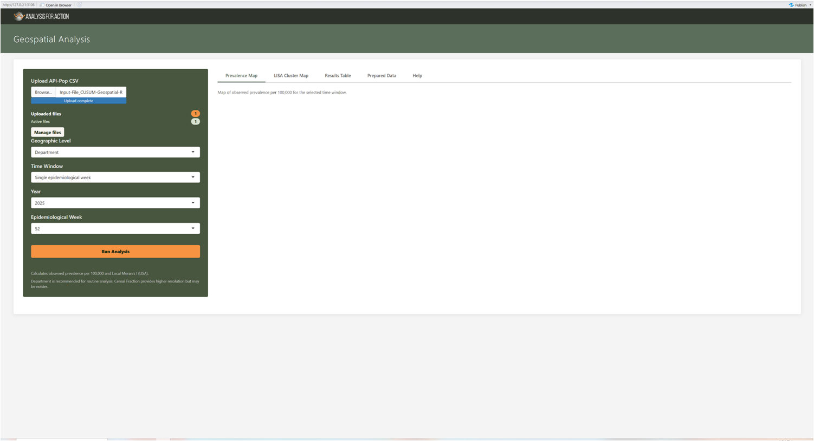Figure 2. Input data

3. Configure and run

Use the following steps to run the analysis:
- Upload one or more CSV files.
- Use Manage files to activate, deactivate, remove or clear files.
- Select a Country when several are configured.
- Choose the Geographic Level.
- Choose Single Week or Week Range.
- Select the Year and the epidemiological week or range.
- Select Run Analysis.

Current controls
Control | Current behaviour
Manage files | All active files are combined. Deactivating a file removes it from the current analysis, without deleting the original upload.
Geographic Level | elects the administrative level and its configured GeoPackage layer.
Time Mode - Single Week | Uses a single epidemiological week.
Time Mode - Week Range | Aggregates the cases over the selected inclusive range.
Year | Limits the analysis to a single epidemiological year.
Run Analysis | Prepares the data, checks the spatial configuration, loads the geometry, joins the records, computes LISA, and refreshes the maps and tables.

Population handling in week ranges
For week ranges, the cases are summed across weeks. Population is treated as a static denominator: the detailed geographic records are deduplicated before the population is rolled up to the selected level. This prevents repeated weekly population values from being added more than once.

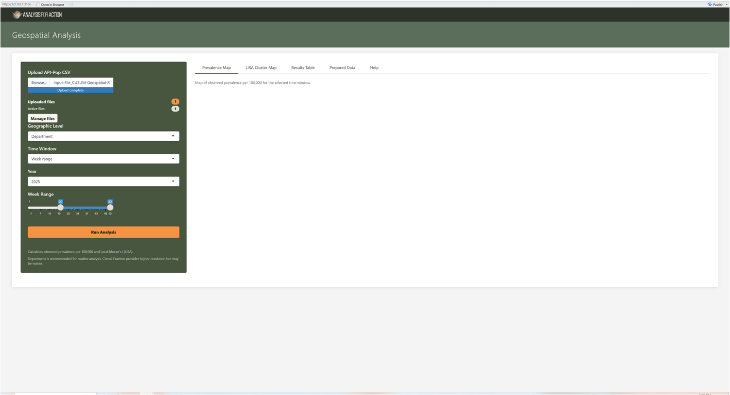
Figure 3. Week ranges.

4. Review the outputs

Global Moran's I banner
The banner above the maps reports Global Moran's I and its p-value. A significant positive value suggests that nearby areas tend to have similar prevalence. A value near zero suggests little overall spatial pattern, whereas a negative value suggests that neighbouring areas tend to differ.

Prevalence map
The prevalence map displays the configured prevalence measure, normally cases per 100,000 people. The legend remains visible at all times. The popups identify the area, the map identifier, the prevalence, the LISA category and the p-value, where available.

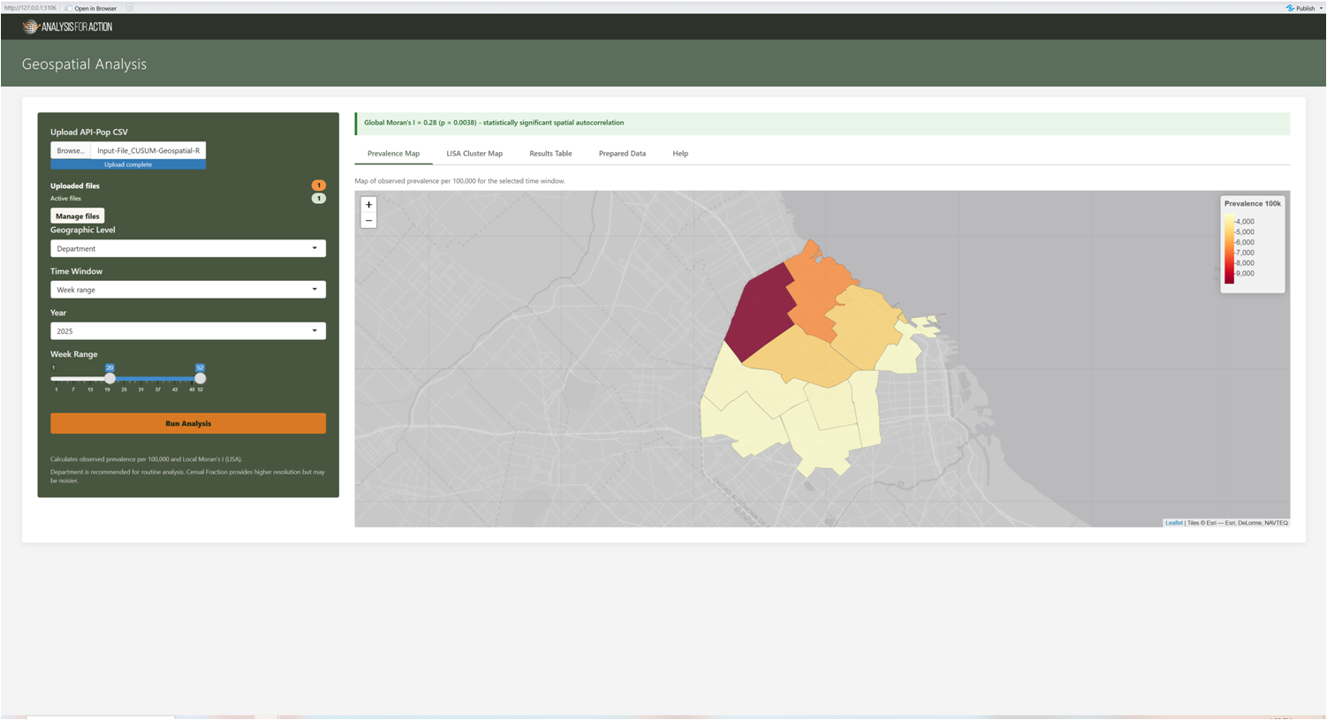
Figure 4. Prevalence map.

LISA cluster map
Category | Meaning
High-High | An area with high prevalence surrounded by areas with high prevalence; a local hotspot pattern.
Low-Low | An area of low prevalence surrounded by areas of low prevalence.
High-Low | A high-prevalence area surrounded by low-prevalence areas; a spatial outlier.
Low-High | A low-prevalence area surrounded by high-prevalence areas; an inverse outlier.
Not Significant | The local pattern did not meet the current p <= 0.05 significance rule.

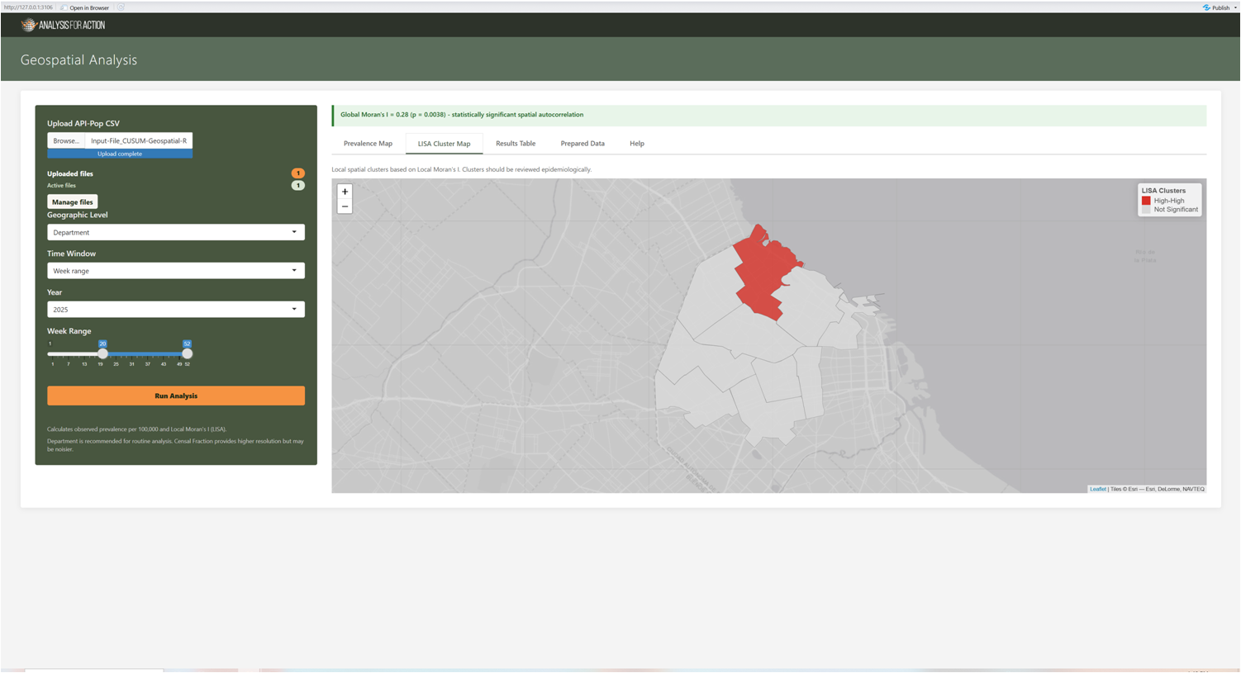
Figure 5. LISA cluster map.

Results table
The results table contains the identifiers, the names, the cases, the population, the weeks included, the prevalence, the LISA category and the p-value, where available. Use Search by to select a text or numeric column and filter the display.
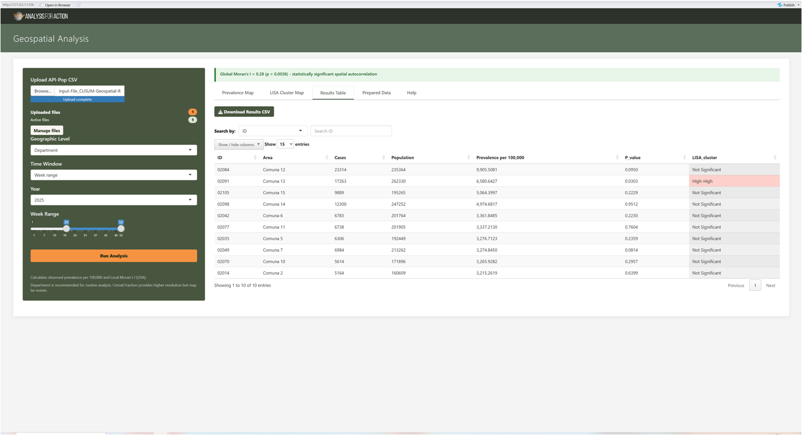
Figure 6. Results table.

Prepared data
This table shows the aggregated dataset before the geometry is displayed, together with the data-preparation log. The log records the time filtering, the case aggregation, the population deduplication, the prevalence calculation and the number of prepared spatial units.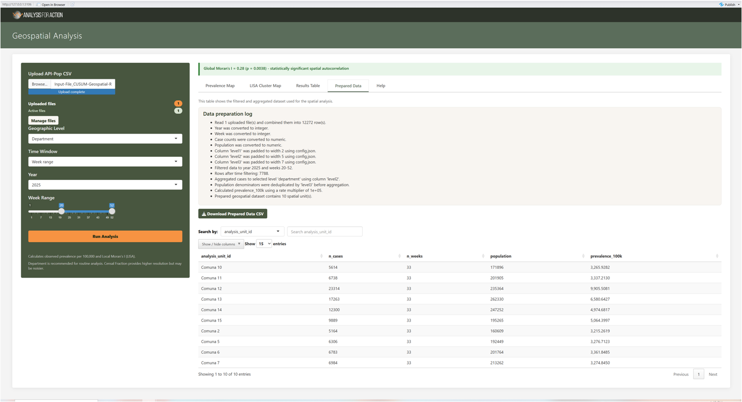
Figure 6. Prepared data.

Display settings
The Help tab can increase interface font size and change table decimal places. The downloaded CSV values retain their full precision.
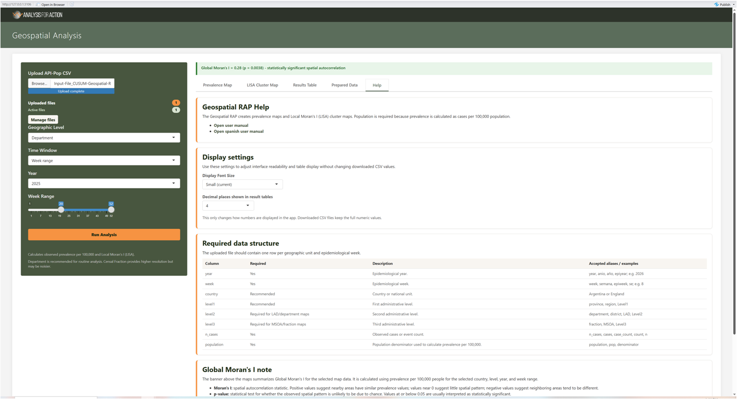
Figure 7. Help tab.

5. Interpret results responsibly
Spatial statistics reward careful reading. The following points set out the main cautions to bear in mind when interpreting the maps and the cluster classifications, so that a detected pattern is not mistaken for a confirmed finding:
- Global Moran's I summarises the entire selected map; it does not identify which individual areas form clusters.
- LISA provides local categories, but the effects of multiple testing and of sparse data should be considered during interpretation.
- A significant cluster may reflect surveillance intensity, population structure, access to services or reporting practices, as well as underlying risk.
- Compare maps across justified time windows, rather than choosing a window only because it produces a desired pattern.
- Before acting on a hotspot or outlier, check the numerator, the population denominator, the identifier match, the selected weeks and whether the neighbouring polygons are epidemiologically meaningful for the question.

6. Downloads
The tool provides several download options, so that results and prepared data can be examined, reported or shared outside the application. The following outputs are available:
Download | Contents
Download Results CSV | The tabular geospatial results for all matched units.
Download Prepared Data CSV | The aggregated input used for the spatial join and the prevalence calculation.
Map export, where enabled | An image of the current interactive map. Its availability depends on the screenshot packages installed in the deployment.

On-screen filters and decimal formatting do not change the underlying downloaded result values.

7. Troubleshooting
The table below lists the problems most likely to arise when running the tool, together with what to check in each case:
Problem | What to check
Geographic data are not available | The configured raw_data/<file_name>.gpkg file may be missing.
Layer or column pre-flight error | Check layer_name, spatial_id, name_col or label_col in config.json.
Spatial join failure | The CSV codes do not match the map IDs or labels. Check the leading zeros, the level selection and the code length.
No data available | The active files may not contain the selected year or weeks.
No Global Moran banner | Fewer than four matched units, all values missing, zero variance, or an invalid neighbour structure.
LISA values are blank | The same sparse-data or constant-data conditions can prevent the local analysis.
Population error | The population is missing, zero, invalid, or mapped under an unrecognised alias.

Escalation package
When reporting a problem, include the selected country, the geographic level, the year, the week window, the active file names, the preparation log, the pre-flight message and a small, non-sensitive sample of the geographic identifiers.

8. Glossary
Term | Meaning
Prevalence per 100,000 | The number of cases divided by the population and multiplied by 100,000.
Global Moran's I | A whole-map measure of spatial autocorrelation.
Local Moran's I / LISA | A local statistic used to classify clusters and spatial outliers.
Spatial weights | Row-standardised neighbour relationships derived from polygon contiguity.
GeoPackage | A spatial database file containing the configured polygon layers.
Spatial join | The match between the prepared analysis unit id values and the configured map IDs or labels.

